2019 Christmas In The Country:
Old Homestead Farm-8824 US-117, Rocky Point, NC 28457
Craft Vendor Application
**Please read carefully to make sure you complete all of the necessary pieces for approval; incomplete applications will not be approved.
*Vendor spots are based on first come, first serve pending director approval.
*Vendors will be notified via email for acceptance.
Name of Business _____________________________________________
Contact Person _____________________________________________ Email_________________________________________
Address_____________________________________________________________________________________
City, State, Zip__________________________________________
Phone # ___________________________
· Description of products: _________________________________________________________________________________________________________________________________________________________
___________________________________________________
· Submit 3 photos of your current work and a 4th photo of your booth setup. Label each picture with artist's name and media. Photos will not be returned. **YOU MAY EMAIL YOUR PICTURES.**

Vendor Fees: Booth Spaces ***village spaces full***
- Village Weekdays 10’X10’ vendor space: $50 per day/space EXCLUDING DECEMBER 23rd & 24th***
- Village Fridays Saturdays, & Sunday’s 10’X10’ vendor space: $65 per day/space. (December 23rd & 24th prices too)
- Work shop Weekdays 12’X12’ vendor space: $50 per day/space EXCLUDING DECEMBER 23rd & 24th***
- Work shop Fridays Saturdays, & Sunday’s 12’X12’ vendor space: $50 per day/space.(December 23rd & 24th prices too)
***Village: Indoor Ac/heat controlled. Main event barn
Work Shop: Indoor No ac/ heat . Next to main barn

Date(s) Selected:____________________________
(See Calendar for available days)
Vendor Fee total: __________________________________

Make checks payable to “Rocky Point Events”
send to: P.O. Box 1363 Burgaw, NC 28425 ($40 Bounced Check fee)
Page 1 of 4

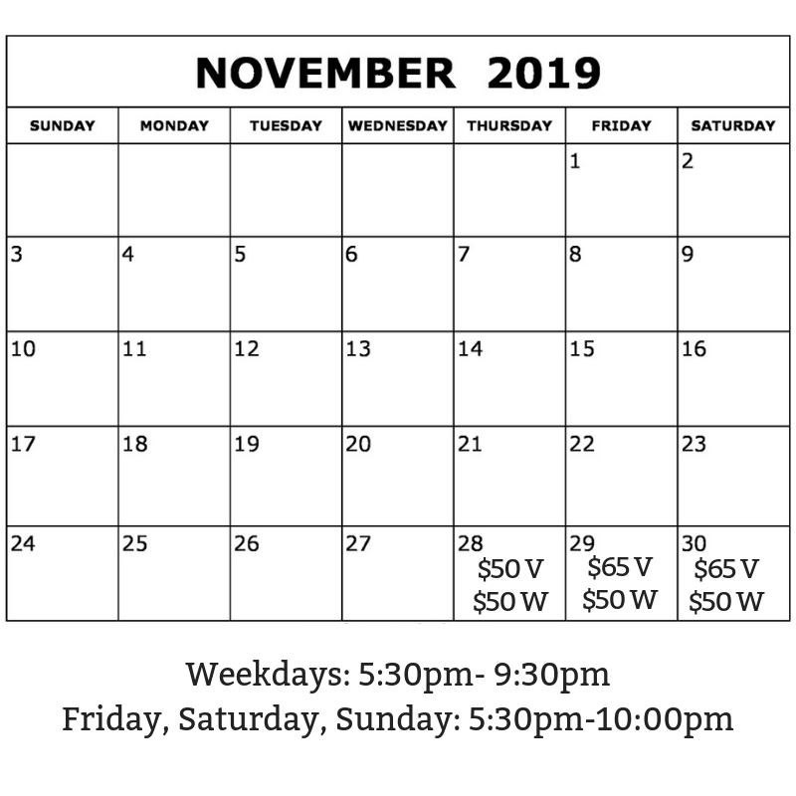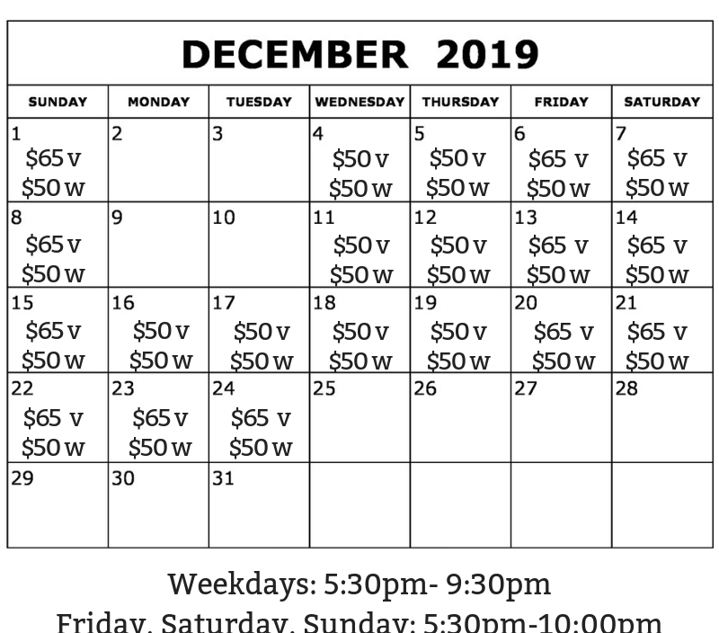

Page 2 of 4

Vendor Expectations & Requirements:
- All products not described on the application or not approved during the application process shall be removed.
- Please keep in mind when our guests visit vendor booths, they associate your actions, products, language, and overall professionalism with “Christmas In The Country”. We expect all vendors to present, speak, and act with professionalism, cheer, and family-friendliness.
- Each exhibitor is responsible for collecting the state Sales Tax and filing a report with the Department of Revenue. Where applicable, a tax ID number may be required.
- An accepted application is a commitment by the exhibitor to display his/her work during ALL scheduled hours of the selected event dates and hours. DO NOT PACK UP EARLY! Exhibitors who break down early may be excluded from future events without refunds.
- BOOTHS MAY NOT BE SHARED/SPLIT etc.
- Vendors are juried individually and accepted for the work they submitted for approval.
- Booth displays need to be designed in an “open” manner. Guests need to be able to step inside your booth area to browse and shop without congesting the event space walkways. (Think U or L shaped) Tents are not permitted indoors.
- Vendors must provide and be solely responsible for their own displays. These displays must be sturdy enough to withstand weather and crowds minimizing potential for injury. Exhibitors will confine their display to their assigned booth space (each space being 10’X10’). We have gone to considerable effort to allow for maximum number of booths in an easy-to-follow configuration and allow for proper and safe aisle space. Expect to be asked to move if you are in any way outside your marked area.
- The exhibitors space must be occupied 30 minutes prior to opening each evening of the show or the exhibitor will be considered a no-show and his/her space may be reassigned and no refund will be given.
- Absolutely no vehicles will be allowed in the event area fifteen minutes prior to event opening. Setup and breakdown times will be strictly enforced. Breakdown will not begin until the end of the night. Vehicles will not be permitted on the grounds until after the event is complete.
- NO REFUNDS will be given! Our hours and dates of operation are weather dependent, and at the discretion of the event director (David Crooks). Rain does not necessarily mean closure, so be prepared until notified otherwise. Any changes and closures are at the discretion of the event director (David Crooks).
- As a guest on the event grounds, all vendors are expected to clean up their area of all trash. This includes sweeping around your products and area.
- As a guest on the event grounds, all vendors are expected to treat event staff, other vendors, and event attendees with respect. Any inappropriate behavior will result in being asked to leave the grounds immediately. Items may be collected after the event is complete. This includes online interactions.
- Vendors are encouraged to share Christmas In The Country posts with positive comments. Do not create “events” on Facebook. We go to great lengths to maintain our social media accounts and communication with our guests, and wish to be the source of all information to the public
- When setting up and tearing down, treat the farm with respect and care: pick up (do not drag) items on floors, drive slowly and stay on the allotted paths. Smoking is not permitted on the farm. Do not move furniture, or place your items or property outside of your allotted booth space.
- If you have any concerns or notice any issues please inform the event Director: David Crooks (910)- 233-8017. Do not confront others (vendors, guests etc).
***All rules must be followed! Please mail completed applications to:
P.O. Box 1363 Burgaw, NC 28425

NOTE: Signature must be from the same vendor as on the application submitted. A signature below signs in agreement to all of the “Vendor Expectations & Requirements” listed above:
SIGNED _____________________________________________ DATED _________
Page 3 of 4

CHRISTMAS IN THE COUNTRY: LIABILITY RELEASE AGREEMENT
I understand that reasonable security will be provided overnight, but I will not hold the Rocky Point Events or its representatives liable for any loss, damage or injury. I further agree to indemnify, save harmless, and defend the Rocky Point Events and its representatives in interest from and against any and all claims, demands, actions, debts, liabilities, and attorney fees arising out of, claimed on account of, or in any manner predicated upon loss or damage to the property of and injuries to or death or any and all persons whatsoever, in any manner caused or contributed to by the vendor, its agents or employees while in, upon, or about the Rocky Point Events grounds where the booth is located, or while going to or departing from the same, and to indemnity and save harmless the Rocky Point Events and its representatives in interest from any liability and that the Rocky Point Events may suffer as the result of acts of negligence, fraud, or misconduct of any vendor's agent or employees on or about the Rocky Point Events grounds. I release the Rocky Point Events from any and all liability for loss or damage to property and merchandise used by the vendor in the operation of the concession due to theft, vandals, fire, storm, flood and damage through any force of nature otherwise. I further grant the Rocky Point Events permission to use any photographs, motion pictures, recordings, or any other record of my participation in the festival for any legitimate reasons.

NOTE: Signature must be from the same vendor as on the application submitted. A signature below signs in agreement to the “LIABILITY RELEASE AGREEMENT”:
SIGNED _____________________________________________
DATED ____________________________________________

Page 4 of 4

